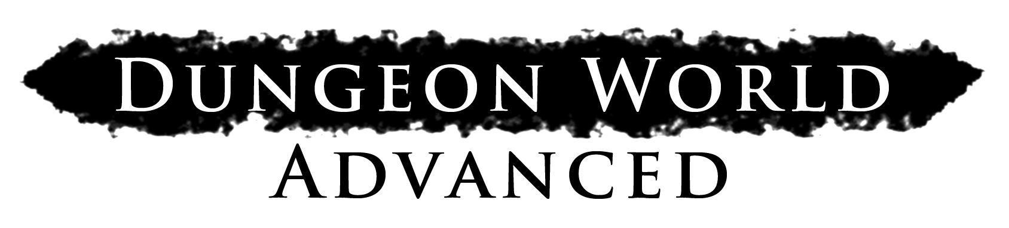

An Update to the Dungeon World RPG Ruleset
Created by Daniel Ries

Version 0.2

With great thanks to the team behind Worlds of Adventure,
For all the content I blatantly stole.

Index

3 Moves
5 Followers
6 Goods and Services
7 Barbarian
9 Bard
11 Cleric
13 Druid
15 Fighter
17 Immolator
19 Paladin
21 Ranger
23 Thief
25 Wizard

Moves

Hack and Slash
When you attack a threatening enemy in melee, roll+Str. On a 7-9, pick one. On a 10+, pick another OR evade the enemy’s counter-attack.
- Deal your damage to the enemy
- Deal an extra d6 damage to them
- Cripple or hinder them, granting an ally +1 Forward against them.

Volley
When you take aim and shoot at an enemy at range, roll+Dex. On a 10+, you have a clear shot—deal your damage. On a 7–9, choose one (whichever you choose you deal your damage):
- You have to move to get the shot placing you in danger as described by the GM
- You have to take what you can get. Roll damage twice and take the worse result.
- You have to take several shots, reducing your ammo by one

Under Pressure
When you make a move while facing down an imminent threat, roll as normal. On a 10+ you may treat your success as a 7-9. If you do, you escape the current threat. Otherwise, you suffer its effects.

Defy Danger
When you attempt to avoid an imminent threat or endure a calamity, say how you deal with it and roll. If you do it
- by powering through, +Str
- by getting out of the way or acting fast, +Dex
- by enduring, +Con
- with quick thinking, +Int
- through mental fortitude, +Wis
- using charm and social grace, +Cha
On a 10+, you do what you set out to, the threat doesn’t come to bear. On a 7-9, you stumble, hesitate, or flinch: the GM will tell you the limits of your victory, or they will give you a hard choice to make.

Defend
When you prepare to defend a person, item, or location under attack, roll+Con. On a 10+, hold 3. On a 7-9, hold 1. As long as you stand in defense, when you or the thing you defend is attacked you may spend hold, 1 for 1, to choose an option:
- Suffer the attack yourself
- Halve the attack’s effects or damage
- Grant the victim +1 to Defy Danger
- Deal d6 damage to the attacker
- Open up the attacker to an ally giving that ally +1 forward against the attacker

Aid or Interfere
When you help or hinder someone you have a Bond with, roll+Bond with them. On a 10+ they take +1 or -2, your choice. On a 7–9 you also expose yourself to danger, retribution, or cost.

Parley
When you try to convince an NPC to do something they don’t want to, using bribery, flattery, deception, or threats, roll+CHA. On a hit, they agree as long as you make them a promise. On a 7-9, they’ll need some concrete assurance of your promise, right now.

Discern Realities
When you take a step back to read a charged situation, roll+WIS. On a 7-9 hold 1. On a 10+ hold 2. Spend your hold as the situation plays out to ask the GM one of the following questions. Take +1 Forward acting on the answer.
- What’s really going on here?
- What’s the best way for me to _____?
On a miss you were so busy gawking that you missed something obvious. Take -1 Forward responding to whatever you missed.

Spout Lore
When you consult your accumulated knowledge about something, roll+INT. On a 7-9 the GM will tell you something new and interesting, but it’s up to you to make it useful. On a 10+ the GM will tell you something interesting and explain how it’s immediately useful to you. On a 6- the GM will tell you something, but you’re not going to like it.

Encumbrance
When you make a move while carrying weight up to or equal to Load, you’re fine. When you make a move while carrying weight greater than your Load, take -1.

Make Camp
When you settle in for the night, unpack your gear and prepare to sleep. If you’re somewhere dangerous, decide the watch order as well.
If you get a decent night’s rest with food and shelter, regain all lost Vigor. Otherwise, regain only a single Vigor.
If you have enough XP you may level up.

Take Watch
When you’re on watch and something approaches the camp, roll+Wis. On a 10+ you’re able to wake the camp and prepare a response, the camp takes +1 forward. On a 7–9 you react just a moment too late; the camp is awake but hasn’t had time to prepare. You have weapons, but no armor and little else. On a miss whatever lurks outside the campfire’s light has the drop on you.

Recover
When you spend a day in bedrest, spend all your Vigor in a Healing Surge. Remove one debility for each 1 you roll. If you are attended by a doctor then automatically remove another debility.

Last Breath
When you’re dying you catch a glimpse of what lies beyond the Black Gates of Death’s Kingdom (the GM will describe it). Then roll (just roll, +nothing—yeah, Death doesn’t care how tough or cool you are). On a 10+ you’ve cheated death— you’re in a bad spot but you’re still alive. On a 7–9 Death will offer you a bargain. Take it and stabilize or refuse and pass beyond the Black Gates into whatever fate awaits you. On a miss, your fate is sealed. You’re marked as Death’s own and you’ll cross the threshold soon. The GM will tell you when.

Moves

Bolster
When you spend your leisure time in study, meditation, or hard practice, you gain preparation. If you prepare for a week or two, 1 preparation. If you prepare for a month or longer, 3 preparation. If have access to a safe, well supplied base of operations (such as a Thief’s Hideout or Wizard’s Sanctum), then reduce the time needed to one day / one week. When your preparation pays off, spend 1 preparation for a +1 to any roll. You can only spend one preparation per roll.

Undertake A Perilous Journey
When you travel through hostile territory, choose one member of the party to act as trailblazer, one to scout ahead, and one to be quartermaster (the same character cannot have two jobs). If you don’t have enough party members or choose not to assign a job, treat that job as if it had rolled a 6. Each character with a job to do rolls+Wis. On a 10+ the quartermaster reduces the number of rations required by one. On a 10+ the trailblazer reduces the amount of time it takes to reach your destination (the GM will say by how much). On a 10+ the scout will spot any trouble quick enough to let you get the drop on it. On a 7–9 each roles performs their job as expected: the normal number of rations are consumed, the journey takes about as long as expected, no one gets the drop on you but you don’t get the drop on them either.

Black Market
When you’re looking to buy something that’s available, but hard to find (magic goods, information, contraband, etc), pay the cost of the item and roll with a +1 bonus for each extra 50% of the base cost you spend greasing palms and opening doors. On a 10+ it’s yours! On a 7-9 pick one:
- You couldn’t find it, but you cut your losses. Recover half your coin.
- You found it, but there’s an extra cost, or strings attached. The GM will tell you what.
- You found someone who can make it or track it down for you. The GM will tell you how long it will take.
On a 6- you got bamboozled! Pick one and draw unwanted attention.

Outstanding Warrants
When you return to a civilized place in which you’ve caused trouble before, roll+Cha. On a hit, word has spread of your deeds and everyone recognizes you. On a 7–9, that, and, the GM chooses a complication:
- The local constabulary has a warrant out for your arrest
- Someone has put a price on your head
- Someone important to you has been put in a bad spot as a result of your actions

Recruit
When you put out word that you’re looking to hire help, describe what you’re looking for and roll. Take +1 each if you...
- have a useful reputation around these parts
- make it known that your pay is generous
- make it known what you’re setting out to do
- make it known that they’ll get a share of whatever you find
On a 10+, you found exactly who you were looking for, or someone just as good. On a 7–9, they seem competent but they’re not quite what you hoped for. On a miss, you got an an applicant who spells trouble and won’t take no for an answer.

Carouse
When you return triumphant and throw a big party, spend 100 coins and roll +1 for each extra 50 coins you spend. On a hit, choose two. But on a 9-, you are also entangled, ensorcelled, or tricked.
- You befriend a useful NPC.
- You hear rumors of an opportunity.
- You gain useful information.
You can only carouse when you return triumphant. That’s what draws the crowd of revelers to surround adventurers as they celebrate their latest haul. If you don’t proclaim your success then who would want to party with you anyway?

Bond
Once per session, when a character helps or hinders you in fulfilling your alignment, you may create a bond with each other, starting at +1. If you already had a bond with them, you may instead strengthen the bond, up to +3.
When a character persuades you to change your alignment, mark XP equal to the bond you had with one another (if any). Then reduce all bonds by 1 and choose (or write) a new alignment that reflects your character’s growth.

End Of Session
When you reach the end of a session, update your Bonds and, if applicable, your Alignment. Once bonds have been updated look at your alignment. If you fulfilled that alignment at least once this session, mark XP. Then answer these three questions as a group:
- Did we overcome a notable monster or enemy?
- Did we loot a memorable treasure?
- Did we learn something new and important about the world?
For each “yes” answer everyone marks XP.

Level Up
When you have downtime (hours or days) and XP equal to (or greater than) your current level+7, subtract your current level +7 from your XP, increase your level by 1, and choose a new advanced move from your class. Choose one of your stats and increase it by 1 (this may change your modifier). Note that changing your Constitution increases your maximum and current HP. Ability scores can’t go higher than 18.

Tags
Clumsy: -1 Ongoing to rolls made with DEX
Tiring: -1 Max Vigor
Brutal: when an attack is Brutal, roll for damage. Then roll again. Take whichever result was better.
Concentration: prevents you from doing anything complicated, like attacking, climbing, breakdancing, etc. If you can’t do it with your eyes closed, you probably can’t do it while concentrating. Certain things might break your concentration, unless you defy danger!
Encounter: a period of intense action, during which the player characters generally don’t have time to stop and smell the roses, adjust their makeup, etc. If the players are sitting around tending to their wounds, catching their breath, or talking about what just happened, the encounter has ended

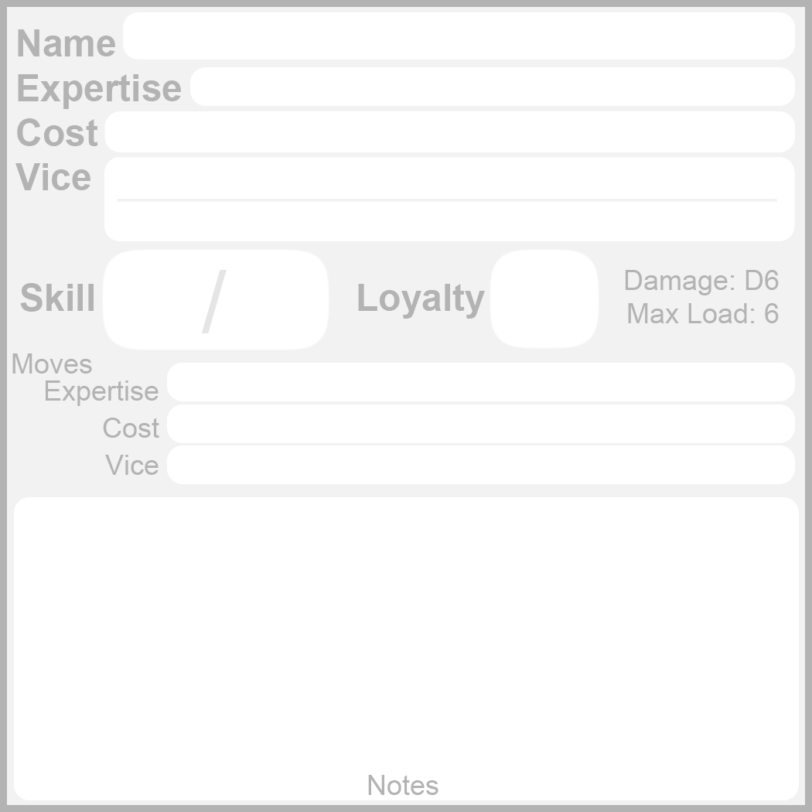
Followers
Followers have 5 main aspects:
- Expertise is their trade, what they’re good at doing. Followers generally only have a single Expertise, which could be “tracking”, or “sailing”, or “medicine”, etc.
- Skill is how well they perform tasks related to their Expertise. It is a modifier that ranges from -1 (poor) to +3 (masterful).
- Loyalty is how willing they are to risk their neck, or perform degrading tasks. It is a modifier that ranges from -2 (resentful) to +3 (devoted). When a Follower’s Loyalty would be reduced to -3, they become mutinous and will abandon or betray the Players at the next opportunity.
- Cost is what they demand in return for their service. It can be tangible, such as wealth, or intangible, such as glory and friendship. When a Follower’s Cost is paid, their Loyalty goes up by one.
- Vice is a Follower’s primary character flaw, the thing they do that tends to cause trouble.
When a Follower is created, the GM writes down 3 moves: one describing how they use their Expertise to help the players, one describing how they pursue their Cost, and one describing how their Vice leads them to trouble. The GM may choose to use these moves when the players look to the GM to see what a Follower does, or when the players give the GM a golden opportunity.

Do Their Thing
When a Follower does something covered by their expertise, they roll+Skill. On 10+, they do it as well as you’d expect. On a 7-9 they falter and reveal an unforeseen problem. On a 6- they get in over their heads.

Give Orders
When you order a follower to do something dangerous, degrading, or contrary to their Vice, roll+Loyalty. On a hit, they agree. But on a 7-9, the GM picks one:
- Their Loyalty is reduced by 1
- They take their sweet time
- They complain loudly, and want something in return

Assist
When a follower assists you in a task that requires a roll, take +1 to the roll, but know that they will be exposing themselves to any danger you incur.

Additionally, when a follower helps you Hack and Slash or Volley, deal an extra d4 damage.

When a follower helps you Defend, you may spend a Hold to grant +d4 armor to yourself or an ally.

Damage & Danger
When a Follower deals damage by themselves, they deal d6 damage.
When a follower would suffer significant damage or get in over their head, and the players don’t come to their aid, the GM will pick one:
- They get themselves out of trouble, but they’ll remember this: -1 Loyalty.
- They get injured or lose something they needed: -1 Skill until they are made whole.

Example Costs
Roll 2d6, pick one, or write your own:
2-3 Take a risk to help them
4 Put down a threat to their home
5 Take down a mighty foe in battle
6 Indulge in drink, gambling, sex, mischief, etc
7 Find treasure (and give them an equal share)
8 Give them credit for one of your triumphs
9 Help them exact revenge on an enemy
10 Discover a great wonder of the wider world
11-12 Perform a deed of pure hearted good

Example Vices
Roll 1d6, pick one, or write your own:
1 Hold grudges and seek payback
2 Indulge too much when given the chance
3 Hew to a superstition or inconvenient tradition
4 Take more than they have a right to
5 Treat others as beneath them
6 Slack off and take the easy way

Goods and Services

Miscellaneous
Adventuring Gear 20 coins, 5 uses, 1 weight
Adventuring​ ​gear​ ​is​ ​a​ ​collection​ ​of​ ​useful​ ​mundane​ ​items​ ​such​ ​as chalk,​ ​poles,​ ​spikes,​ ​ropes,​ ​etc.​ ​When​ ​you​ ​rummage​ ​through​ ​your adventuring​ ​gear​ ​for​ ​some​ ​useful​ ​mundane​ ​item,​ ​you​ ​find​ ​what you​ ​need​ ​and​ ​mark​ ​off​ ​a​ ​use.
Bag of Books 10 coins, 5 uses, 2 weight
When your bag of books contains just the right book for the subject you’re spouting lore on, consult the book, mark off a use, and take +1 to your roll.

Halfling Pipeleaf 5 coins, 3 uses, 0 weight
When you share halfling pipeleaf with someone, expend a use and take +1 forward to parley with them.
Flask of Alcohol 5 coins, 2 uses, 0 weight
When you need a little liquid courage before doing something scary, risky, crazy, or just plain stupid, mark off a use and take +1 Forward. It also burns rather well...
Keg of Dwarven Stout 20 coins, 4 weight
When you open a keg of dwarven stout and let everyone drink freely, take +1 to your Carouse roll. If you drink a whole keg yourself, you are very, very drunk.
Pretty Trinket 5 coins
A simple, but pretty gift. Impresses peasants and adventurers.
Dungeon Rations 10 coins, rations, 5 uses, 1 weight
Not tasty, but not bad either.
Personal Feast 10 coins, rations, 1 use, 1 weight
Ostentatious to say the least. Gain +1 Max Vigor after you consume. Effect lasts about a day.
Bandages 10 coins, 3 uses, slow, 0 weight
Grants +D4 healing during a Healing Surge.
Poultices and Herbs 20 coins, 2 uses, slow, 1 weight
In Healing Surge, heal +D4 and remove 1 debility if you roll a 1

Potions

Antitoxin 10 coins, 1 use, 0 weight
Cures a single poison.

Mana 40 coins, 1 use, 0 weight
Take +1 Ongoing to cast spells, for an encounter

Healing 50 coins, 1 use, 0 weight
Restores 10 hp, or removes 1 debility

Power 70 coins, 1 use, 0 weight
Take +1 Ongoing, for an encounter

Vigor 80 coins, 1 use, 0 weight
Restores all Vigor

Weapons

2x Throwing Daggers 5 coins, thrown, 0 weight

Hatchet 5 coins, hand, thrown, 1 weight

Spear 5 coins, reach, thrown,1 weight

Staff 2 coins, reach, 2 handed, 1 weight

Dagger / Shiv 2 coins, hand, 1 weight

Axe / Mace / Warhammer / Shortsword
15 coins, close, 1 weight
Flail / Battle Axe / Longsword
30 coins, close, +1 damage, 2 weight

Halberd / Greatsword

50 coins, reach, forceful, +1 damage, 2 handed, 2 weight

Rapier 20 coins, close, precise, 1 weight

Dueling Rapier 60 coins, close, 1 piercing, precise, 1 weight

Bows

Ragged Bow 20 coins, near, 2 weight

Fine Bow 40 coins, near, far, 2 weight

Hunter’s Bow 100 coins, near, far, 1 weight

Crossbow 20 coins, near, +1 damage, reload, 3 weight

Arrows 5 coins, 3 ammo, 1 weight

Elven Arrows 15 coins, 4 ammo, 1 weight

Firearms

Matchlock Pistol 80 coins, near, 2 piercing, messy, reload, 1 weight

Matchlock Rifle 160 coins, near, far, 2 piercing, +1 damage, messy, reload, 3 weight

Ammo Box 30 coins, 5 ammo, 2 weight

Armor and Shields

Shield 10 coins, +1 armor, 2 weight

Leather / Chain Armor 20 coins, 1 armor, worn, 1 weight

Scale Mail 50 coins, 2 armor, worn, clumsy, tiring, 3 weight

Brigandine 90 coins, 2 armor, worn, tiring, 2 weight

Plate Armor 200 coins, 3 armor, worn, clumsy, tiring, 5 weight

Fitted Plate 420 coins, 3 armor, worn, clumsy, tiring, 3 weight

Spell Beads
When crushed, spell beads provide a single error-free casting of a specific Cleric or Wizard spell. Wizards use them to learn new Arcane spells. Effects last a max of one hour, if Ongoing.

Level 1 Spell Bead 30 coins, 1 use, 0 weight

Level 3 Spell Bead 50 coins, 1 use, 0 weight

Level 5 Spell Bead 100 coins, 1 use, 0 weight

Poisons
2x Bloodweed 20 coins, touch, dangerous, 0 weight
Until cured, the target deals d4 less damage on all their attacks.

2x Serpent’s Tears 20 coins, touch, dangerous, 0 weight
Target takes +2 damage from all sources.

2x Oil of Tagit 30 coins, applied, dangerous, 0 weight
The target falls into a light sleep.

2x Goldenroot 40 coins, applied, dangerous, 0 weight
The target treats the next creature they see as a trusted ally for about a day, or until proven otherwise.

Transportation

Cart & Donkey 50 coins, load 20

Horse 70 coins, load 10

Ox-drawn Wagon 90 coins, load 40

River Boat 150 coins, load 20

War Horse 400 coins, load 10

Services

A night’s stay at a respectable inn 5 coins
Includes food and drink.

A week’s stay at a peasant inn 5 coins
You’re going to look and smell awful after spending a night here.

A guide to the city 5 coins
They’ll tell you which alleys to steer clear of, and help you find anyone you’re looking for.

A night’s entertainment 15 coins
Song, dance, “companionship”...

Healing from a doctor 5 coins
Spend the day in their care to remove a debility.
Dirt on Someone 10 coins
If you need to know someone’s shameful secrets.
A Run-of-the-Mill Killing 20 coins
Effective, if not professional.
